AWARDS

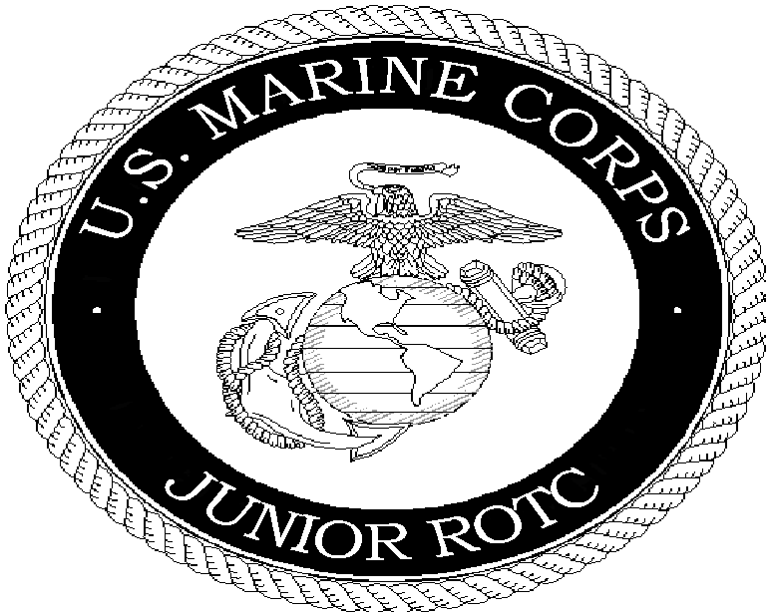

JUL 2014

AWARDS

CRITERIA AND DESCRIPTION OF MEDALS AND RIBBONS

Awards shall be worn in the order of precedence presented here, from top down and from the wearer's right to left, unless otherwise specified herein.

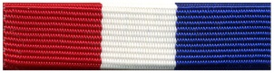
1. Legion of Valor Bronze Cross for Achievement

a. Criteria:

(1) Cadets must have an MCJROTC class standing in the top 25 percent of their class to be considered.

(2) Have a school academic class standing in the top 25 percent of their class to be considered.

(3) Have demonstrated exemplary military leadership.

(4) Have demonstrated academic leadership (demonstrated qualities of leadership in scholastic activities, student organizations, community activities, and interscholastic athletic participation).

(5) Nominees MUST be enrolled in MCJROTC their senior year in order to be eligible for this award

b. Selection:

(1) Nomination by Senior Marine Instructor.

(2) Selection by Commanding General, Training and Education Command, Quantico, VA.
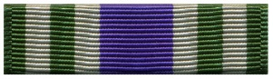
2. MCROA Outstanding Unit Award

a. Criteria: Authorized for those Cadets whose unit received recognition by placing first in competition for the outstanding MCJROTC unit.

b. Selection by Commanding General, Training and Education Command, Quantico, VA.
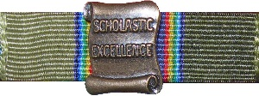
3. American Legion Award for Scholastic Excellence

a. Criteria:

(1) Cadets must have an academic average earned on all courses other than MCJROTC in the upper 10 percent of the class.

(2) Have grades in all MCJROTC subjects within the top 25 percent of that unit.

(3) Have demonstrated qualities of leadership.

(4) Have actively participated in related student activities such as student organizations, constructive activities, or sports.

b. Selection: The Senior Marine Instructor will select one eligible Cadet for this award.

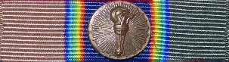
4. American Legion Award for Military Excellence

a. Criteria:

(1) Be in the upper 25 percent of the class in academic standing, including all MCJROTC subjects.

(2) Have demonstrated outstanding qualities in military leadership, discipline, character, and citizenship.

b. Selection: The Senior Marine Instructor will select one eligible Cadet for this award.
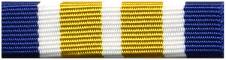
5. Sons of the American Revolution (SAR) Medal

a. Criteria: Awarded to an LE-II or LE-III Cadet in their junior year who has exhibited the highest standards of leadership, soldierly bearing, and excellence.

b. Selection: The Senior Marine Instructor will select one eligible Cadet for this award.

6. Daughters of the American Revolution (DAR) Medal
a. Criteria: Awarded to a graduating Cadet.

(1) The graduating Cadet must be in the upper 25 percent of the graduating class in all subjects, including MCJROTC.

(2) Have demonstrated qualities of dependability and good character, adherence to military discipline, leadership ability, and fundamental and patriotic understanding of the importance of JROTC training.

b. Selection: The Senior Marine Instructor will select one eligible Cadet for this award.

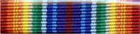
7. Military Order of the World Wars (MOWW) Medal

a. Criteria: This award is presented to an outstanding first year Cadet.

(1) The Cadet must excel in both military and scholastic activities during the year.

(2) Be in good standing in all military and scholastic courses at the time of selection and presentation of the award.

(3) Have indicated, by grades, extracurricular activities, and individual endeavor, a desire to serve the United States.

b. Selection: The Senior Marine Instructor will select one eligible Cadet for this award.
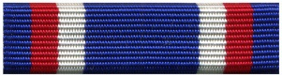
8. Military Officers Association of America (MOAA) Medal

a. Criteria: Presented to a Cadet for outstanding academic achievement.

(1) The Cadet must be in the top 10 percent of the class.

(2) Have an "A" average in MCJROTC subjects.

(3) Hold an officer's billet in the unit.

(4) Be in their junior year of high school.

b. Selection: The Senior Marine Instructor will select one eligible Cadet for this award.
9. Veterans of Foreign Wars (VFW) Medal

a. Criteria: This award is presented to the Cadet who possesses individual characteristics contributing to leadership both in and out of uniform.

(1) The Cadet must have a minimum grade of "B" in MCJROTC and "C" in overall school academics.

(2) The Cadet must be active in at least one other extracurricular activity or club and may not be a former recipient of the award.

b. Selection: The Senior Marine Instructor will select one eligible Senior, Junior, and Sophomore for this award.

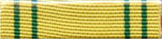
10. Daedalian Medal

a. Criteria: Awarded to an LE-III Cadet in their junior year who has demonstrated an understanding and appreciation of patriotism, love of country and service to the nation.

(1) The Cadet shows a desire and potential to pursue a military career.

(2) Is ranked in the upper 10 percent of the MCJROTC junior class.

(3) And is in the top 20 percent of the school's junior class.

b. Selection: The Senior Marine Instructor will select one eligible Cadet for this award.

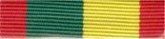
11. Women Marines Association (WMA) Award (Ribbon)

a. Criteria: Presented annually to the outstanding Cadet in the unit.

(1) The Cadet must be participating in LE-II or higher.

(2) Must have satisfactory record of academic accomplishment and citizenship.

(3) Must have the highest leadership education grades in the MCJROTC unit.

b. Selection: The Senior Marine Instructor will select one eligible Cadet for this award.

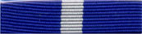
12. Non-Commissioned Officers Association (NCOA) Medal

a. Criteria: Awarded annually to the most outstanding Cadet NCO in the unit during the past school year.

(1) The Cadet must be participating in LE-II or higher.

(2) Must be in the rank of Cadet Corporal thru Cadet Sergeant Major.

(3) Must have consistently exhibited the highest military bearing, personal appearance, deportment, and leadership ability.

b. Selection: The Senior Marine Instructor will select one eligible Cadet for this award.

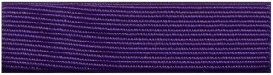
13. Military Order of the Purple Heart Medal

a. Criteria: Awarded annually (in May) to an LE-II or LE-III Cadet who:

(1) Holds a leadership billet in the unit.

(2) Has maintained at least a "B" average in all classes.

(3) Not previously a recipient.

b. Selection: The Senior Marine Instructor will select one eligible Cadet for this award.

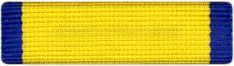
14. Navy League Youth Medal

a. Criteria: Awarded annually (in May) to an LE-II or LE-III Cadet at least a junior who:

(1) Has displayed strong character.

(2) Has consistently demonstrated discipline and leadership.

(3) Has consistently demonstrated dedication to the program.

b. Selection: The Senior Marine Instructor will select one eligible Cadet for this award.

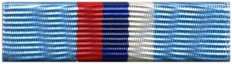
15. Reserve Officers Association Medal

a. Criteria: Awarded annually (in May) to an LE-II or LE-III Cadet at least a junior who:

(1) Has displayed exemplary leadership.

(2) Has maintained an "A" average in MCJROTC.

(3) Has maintained at least a "C" average in all other courses.

b. Selection: The Senior Marine Instructor will select one eligible Cadet for this award.
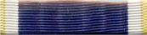
16. Naval Reserve Association Medal

a. Criteria: Awarded annually (in May) to an LE-II or LE-III Cadet at least a junior who:

(1) Has displayed strong character.

(2) Has consistently demonstrated discipline and leadership.

b. Selection: The Senior Marine Instructor will select one eligible Cadet for this award.
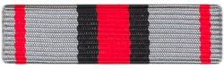
17. American Veterans (AmVets) Medal

a. Criteria: Awarded annually (in May) to an LE-II or LE-III Cadet who:

(1) Has displayed strong character.

(2) Has maintained an "A" average in MCJROTC.

(3) Has maintained at least a "C" average in all other courses.

b. Selection: The Senior Marine Instructor will select one eligible Cadet for this award.
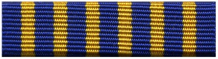
18. National Sojourners Medal

a. Criteria: Presented annually to an enrolled Cadet, a sophomore or junior, not previously a recipient.

(1) The Cadet must be enrolled for the next year.

(2) Is in the top 25 percent of the MCJROTC class.

(3) Has encouraged and demonstrated the ideals of Americanism.

b. Selection: The Senior Marine Instructor will select one eligible Cadet for this award.
19. Scottish Rite Leadership Medal

a. Criteria: Awarded annually (in May) to the LE-III Cadet who:

(1) Has displayed strong character.

(2) Is in the top 25 percent of the MCJROTC class.

(3) Is active in community service activities.

b. Selection: The Senior Marine Instructor will select one eligible Cadet for this award.

20. Outstanding Cadet Ribbon
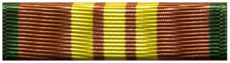
a. Criteria: Presented annually to the one Cadet from each year group who demonstrates:

(1) Consistently superior performance in all facets of the Leadership Education Course.

(2) Academic achievement in the top 25 percent of the class in all academic subjects including MCJROTC.

(3) Exceptional qualities of leadership, discipline, character, military bearing, and military proficiency.

b. Selection: The Senior Marine Instructor will select eligible Cadets for this award.

c. Device: The bronze, silver, and gold Marine Corps emblem device shall be used to denote second, third and fourth awards, respectively.
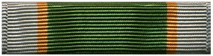
21. Student Leadership Ribbon

a. Criteria: Presented to any Cadet who holds an elected office in the student body of the school or the offices of president or vice president in any school sponsored club or organization.

b. Award: The Cadet must inform the SMI or MI during the period of eligibility in order to receive this award.

c. Device: The bronze, silver, and gold Lamp of Learning device shall be used to denote second, third and fourth awards, respectively.
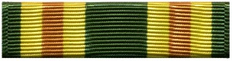
22. Officer Leadership Ribbon

a. Criteria: Presented annually (in May) to those Cadet Officers who have consistently demonstrated exceptional leadership qualities, discipline, character, military bearing, and military proficiency.

b. Selection: The Senior Marine Instructor will select eligible Cadets for this award.

c. Device: The bronze Marine Corps emblem device shall be used to denote a second award.

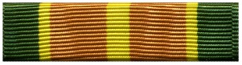
23. Non-Commissioned Officer Leadership Ribbon

a. Criteria: Presented annually (in May) to those Cadet Non-Commissioned Officers who have consistently demonstrated exceptional leadership qualities, discipline, character, military bearing, and military proficiency.

b. Selection: The Marine Instructor will select eligible Cadets for this award.

c. Device: The bronze and silver Marine Corps emblem device shall be used to denote second and third awards, respectively.
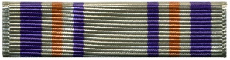
24. Civic Service Ribbon

a. Criteria: Presented to those Cadets who have achieved 20 hours of MCJROTC sponsored community service activities.

b. Award: Automatic upon eligibility.

c. Device: The bronze, silver, and gold Marine Corps emblem device shall be used to denote second, third and fourth awards, respectively.
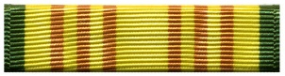
25. Best Drill Cadet Ribbon

a. Criteria: Presented annually (in May) to the first, second, or third year Drill Team Cadet who demonstrates superior performance in comparison with other Cadets in the following categories:

(1) Overall abilities in close order drill.

(2) Military bearing and appearance.

(3) Level of commitment to the team.

b. Selection:

(1) Each respective Drill Team Commander will nominate one Cadet for this award.

(2) Nomination approval by Senior Marine Instructor.

c. Device: The bronze and silver Marine Corps emblem device shall be used to denote second and third awards, respectively.

26. Distinguished Scholastic Achievement Ribbon

a. Criteria: Presented to those Cadets who have maintained an "A" or "B" semester average (80 percent or higher on semester report card) in all courses.

b. Award: The Cadet must present to the SMI or MI their semester report card in order to receive this award. End of year report cards must be presented at the beginning of the following school year and will be credited to the previous school year. Only one award per year will be authorized.

c. Device: The bronze, silver, and gold Lamp of Learning device shall be used to denote second, third and fourth awards, respectively.

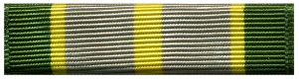
27. Arts and Academics Ribbon

a. Criteria: Presented to those Cadets who participate in interscholastic competition or advancement of the MCJROTC program through the arts.

b. Award: The Cadet must inform the SMI or MI of eligibility in order to receive this award. Only one award per year will be authorized.

c. Device: The bronze, silver, and gold Lamp of Learning device shall be used to denote second, third and fourth awards, respectively.

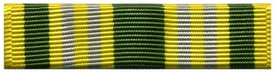
28. Distinguished Military Training Ribbon

a. Criteria: Presented annually to those Cadets who:

(1) Qualify "Expert" during marksmanship training.

(2) Score at least 400 (for males) or 350 (for females) on either Physical Fitness Test.

(3) Score at least 90% on final drill evaluation.

b. Award: The Cadet must inform the SMI or MI of eligibility in order to receive this award.

c. Device: The bronze, silver, and gold Marine Corps emblem device shall be used to denote second, third and fourth awards, respectively.

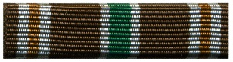
29. Physical Achievement Ribbon

a. Criteria: Presented to those Cadets who score 300 points or more on any MCJROTC Youth Physical Fitness Test.

b. Award: Automatic upon eligibility. Only one award per year will be authorized.

c. Device: The bronze, silver, and gold Marine Corps emblem device shall be used to denote second, third and fourth awards, respectively.

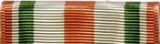
30. Superior Marksman Ribbon

a. Criteria: Presented annually to those Cadets who achieve a score of 250 or better during annual qualification or rifle competition.

b. Award: Automatic upon eligibility.

c. Device: The bronze, silver, and gold Marine Corps emblem device shall be used to denote second, third and fourth awards, respectively.

31. Athletic Participation Ribbon
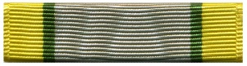
a. Criteria: Presented to those Cadets who participate in interscholastic athletics.

b. Award: The Cadet must inform the SMI or MI of eligibility in order to receive this award. Only one award per year will be authorized.

c. Device: The bronze, silver, and gold Lamp of Learning device shall be used to denote second, third and fourth awards, respectively.
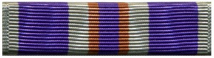
32. Longevity and Fidelity Ribbon

a. Criteria: Presented to all Cadets at the beginning of LE-III and LE-IV.

b. Award: Automatic upon eligibility.

c. Device: The bronze Marine Corps emblem device shall denote first award. The silver Marine Corps emblem device shall denote second award.
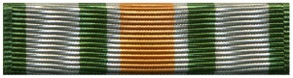
33. Distinguished Conduct Ribbon

a. Criteria: Presented annually (in May) to those Cadets whose conduct and demeanor are worthy of special recognition.

(1) Individuals shall not have received any adverse conduct reports from any staff or faculty member for the entire year.

(2) No ISS Assignments.

(3) No referrals of any kind.

(4) No excessive tardiness to any classes. (Excessive tardiness is defined as five or more tardies total or three tardies to any one period over the course of a school year.)

b. Award: The Cadet must inform the SMI or MI of eligibility. SMI will make the final determination. Only one award per year will be authorized.

c. Device: The bronze, silver, and gold Marine Corps emblem device shall be used to denote second, third and fourth awards, respectively.

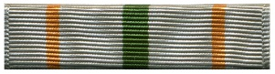
34. Best Drill Squad (Class) Ribbon

a. Criteria: Presented annually (in May) to those Cadets comprising the best drill squad (class). The best drill squad is determined through class average of Cadet's drill grades throughout the year. LE-I classes will be compared to other LE-I classes with LE-II classes compared to LE-II classes. (This award is not authorized for LE-III.)

b. Award: Automatic upon eligibility.

c. Device: The bronze and silver Marine Corps emblem device shall be used to denote second or third awards, respectively.
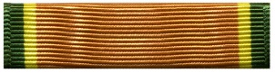
35. Color Guard Ribbon

a. Criteria: Presented to those Cadets who compete as members of the unit's color guard or complete three official color presentations or exhibitions.

b. Award: The Cadet must inform the SMI or MI of eligibility in order to receive this award. Only one award per year will be authorized.

c. Device: The bronze, silver, and gold Marine Corps emblem device shall be used to denote second, third and fourth awards, respectively. (The bronze, silver, and gold bar device, lettered "Color Guard", shall be used to denote second, third and fourth awards, respectively until supplies are exhausted.)
36. Drill Team Ribbon

a. Criteria: Presented to those Cadets who compete as members of the unit's Drill Team.

b. Award: The Cadet must inform the SMI or MI of eligibility in order to receive this award. Only one award per year will be authorized.

c. Device: The bronze, silver, and gold bar device, lettered "Drill Team", shall be used to denote second, third and fourth awards, respectively.
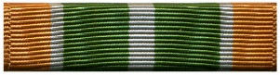
37. Band/Drum and Bugle Corps Ribbon

a. Criteria: Presented to those Cadets who participate as members of the school's band/drum and bugle corps.

b. Award: The Cadet must inform the SMI or MI of eligibility in order to receive this award. Only one award per year will be authorized.

c. Device: The bronze, silver, and gold bar device, lettered "Band", shall be used to denote second, third and fourth awards, respectively.

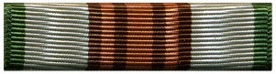
38. Rifle Team Ribbon

a. Criteria: Presented to those Cadets who compete as members of the unit's rifle team.

b. Award: The Cadet must inform the SMI or MI of eligibility in order to receive this award. Only one award per year will be authorized.

c. Device: The bronze, silver, and gold "Rifle Team" bar device shall be used to denote second, third and fourth awards, respectively.

39. Orienteering Ribbon
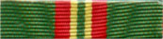
a. Criteria: Presented to those Cadets who compete in an orienteering competition.

b. Award: The Cadet must inform the SMI or MI of eligibility in order to receive this award. This is a one time award only.
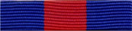
40. Recruiting Ribbon

a. Criteria: Presented to those Cadets who personally recruit a new Cadet into the program who completes LE-I. (Additional eligibility criteria exist and shall be determined solely by the SMI.)

b. Award: The Cadet must inform the SMI or MI of eligibility and the name of the recruit in order to receive this award. Only one award per year will be authorized.

c. Device: The bronze, silver, and gold Marine Corps emblem device shall be used to denote second, third and fourth awards, respectively.

41. Cadet Leadership Camp Ribbon

a. Criteria: Presented to those Cadets who attend a Marine Corps sponsored Cadet Leadership Camp.

b. Award: Automatic upon eligibility.
c. Device: The bronze, silver, and gold Marine Corps emblem device shall be used to denote second, third and fourth awards, respectively.
CRITERIA AND DESCRIPTION OF OTHER AWARDS

1. Honor Grad Plaque

a. Criteria: Presented annually (in May) to the senior with the highest class standing.

b. Award: One plaque awarded per year.

2. "Esprit de Corps" Plaque

a. Criteria: Presented annually (in May) to the Cadet who demonstrates the highest level of commitment and enthusiasm to the program during the year.

b. Award: One plaque awarded per year.

3. "Most Improved Cadet" Plaque

a. Criteria: Presented annually (in May) to the Cadet who demonstrates the most overall improvement during year or from one year to the next.

b. Award: One plaque awarded per year.

4. Community Service Plaques

a. Criteria: Presented annually (in May) to the Cadets from each year of the program who accumulate the most total hours of MCJROTC sponsored community service activities.

b. Award: Four plaques awarded per year.

5. Marksmanship Plaques

a. Criteria: Presented annually (in May) to the Cadets from each year of the program who achieve the highest rifle marksmanship score during annual qualification.

b. Award: Four plaques awarded per year.

6. Youth Physical Fitness Test Plaques

a. Criteria: Presented annually (in May) to the male and female Cadets from each year of the program who achieve the highest scores during the YPFT.

b. Award: Eight plaques awarded per year.

7. Marine Corps League YPFT Certificates

a. Criteria: Presented to those Cadets who achieve a score of 250 or higher on any recorded YPFT. (Inventory YPFT not eligible.)

b. Award: Automatic upon eligibility. Two opportunities available. Eight total certificates possible.

8. Annual Inspection Certificate of Achievement

a. Criteria: Presented to those Cadets with a finding of no discrepancies during an annual personnel inspection.

b. Award: Automatic upon eligibility.

9. Certificate/Letter of Appreciation

a. Criteria: Presented to those deserving Cadets on a case-by-case basis.

b. Award: Automatic as warranted.

10. "Semper Fidelis" Award (Marine Corps NCO Sword and Wall-mount Plaque)

a. Criteria: Presented annually in conjunction with the Outstanding Cadet Ribbon to the Cadet who demonstrates:

(1) Consistently superior performance in all facets of the Leadership Education Course.

(2) Academic achievement in the top 25 percent of the class in all academic subjects including MCJROTC.

(3) Exceptional qualities of leadership, discipline, character, military bearing, and military proficiency.

b. Selection: The Senior Marine Instructor will select one eligible Cadet for this award.

